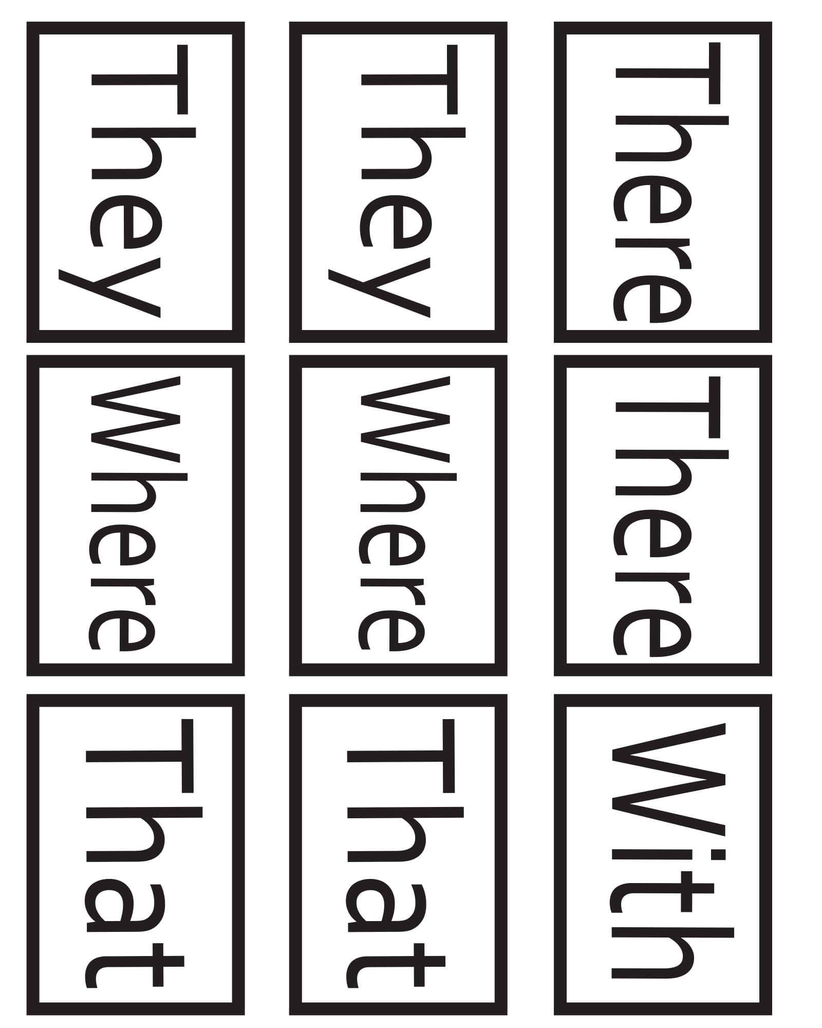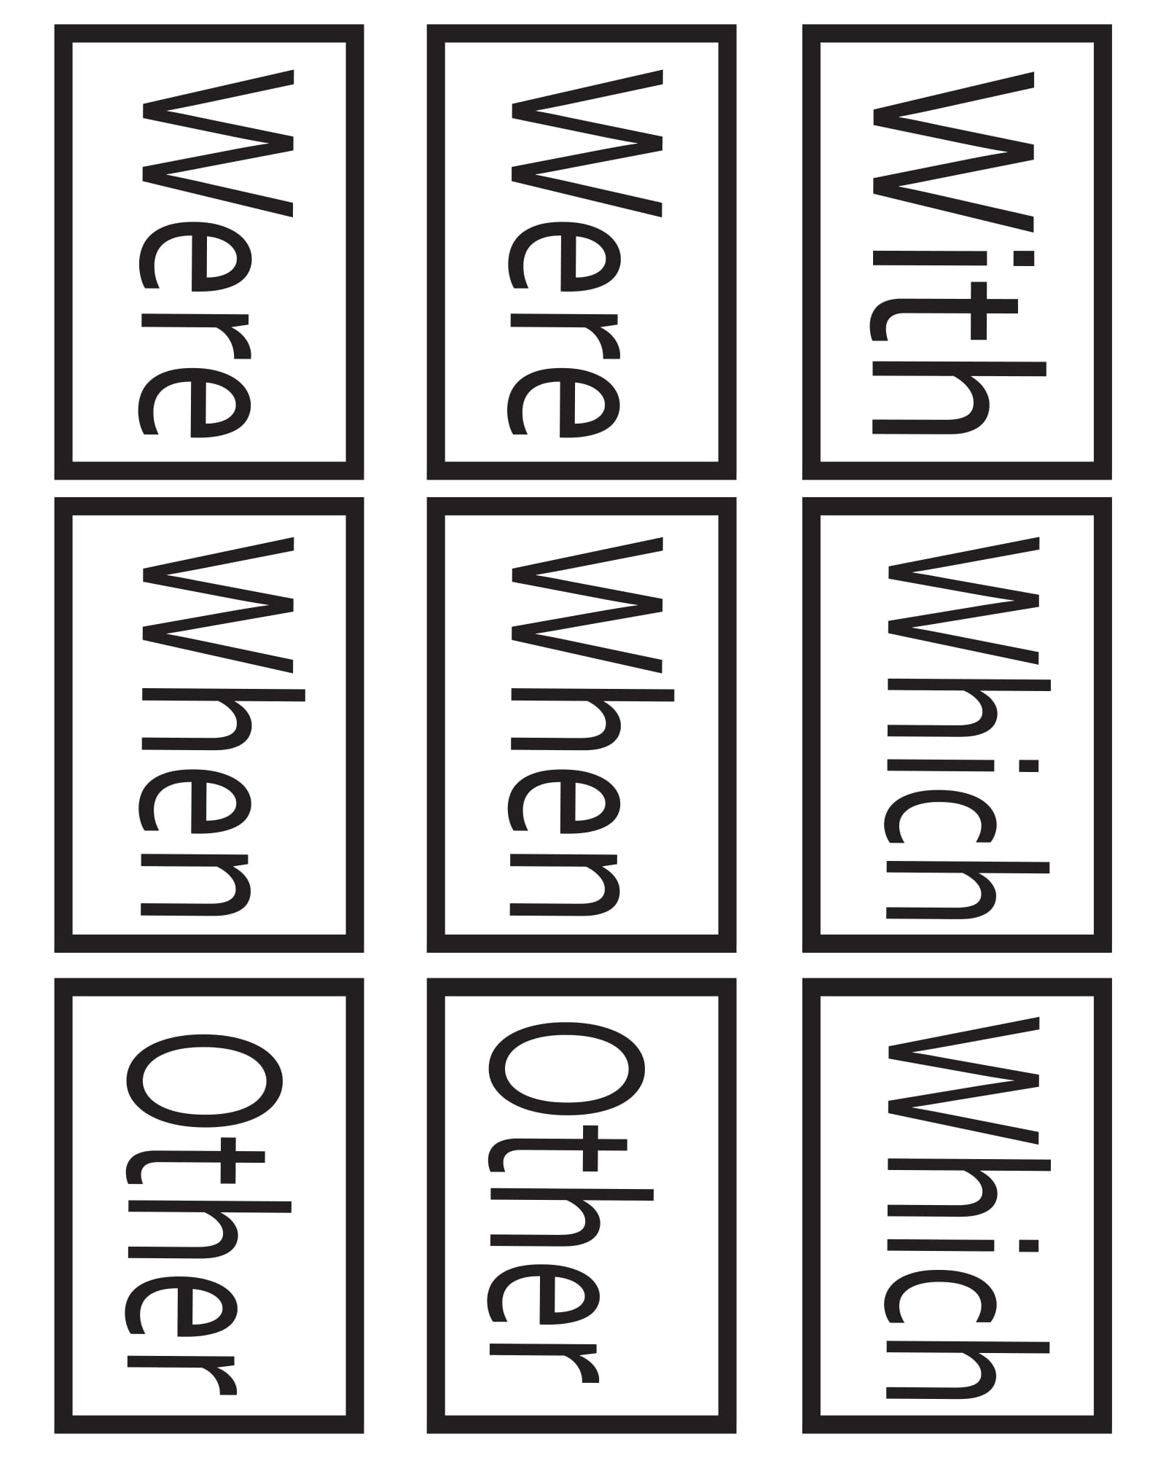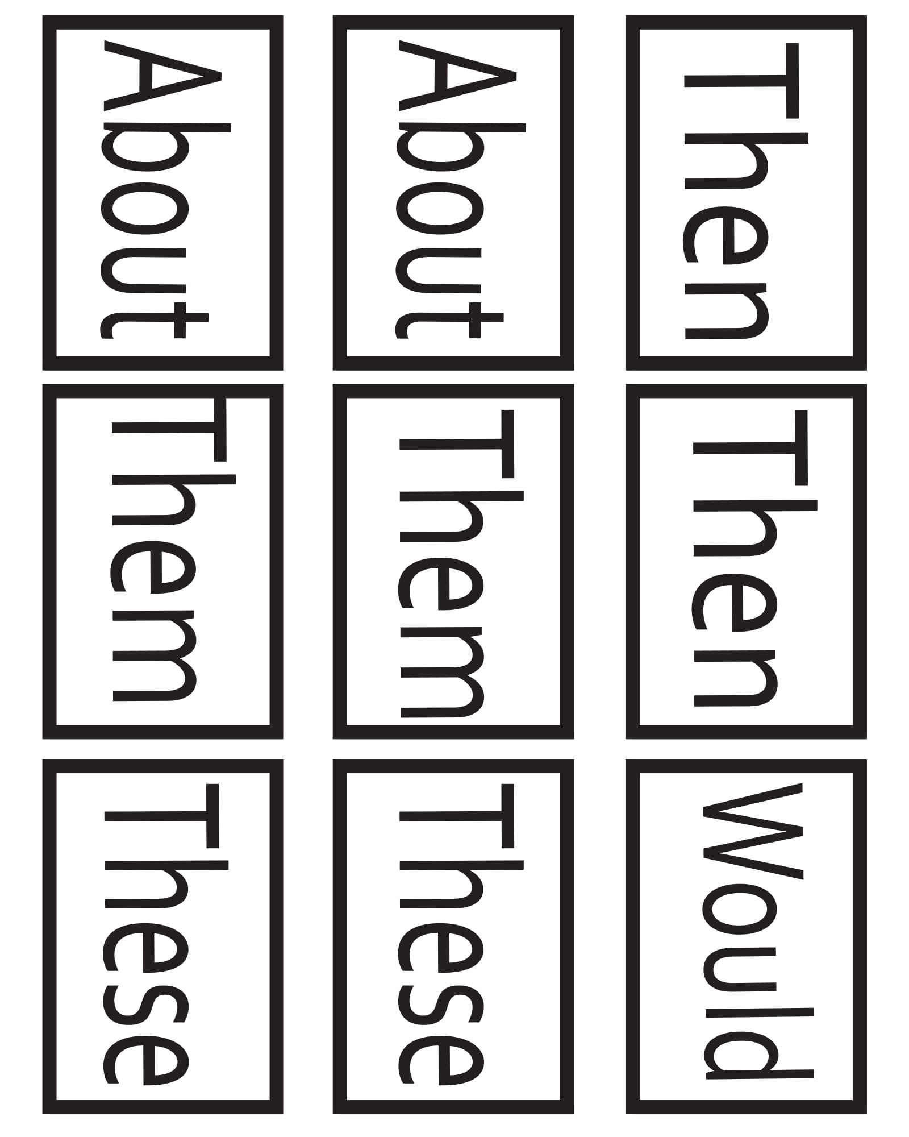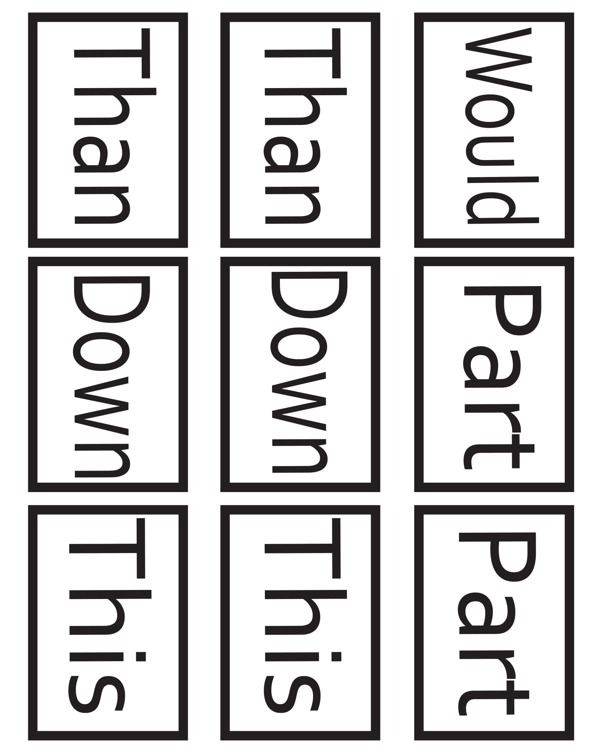

1st Grade Sight Words GO FISH from [WorksheetHero.com](https://www.worksheethero.com/fun-games-to-teach-sight-words-for-a-first-grader/)